Date of Application;____________________
Parcel Identification Number: ___________________________________________ (“Homestead”)
Applicant Information
Name(s): ____________________________________________________________________________
Mailing Address: _____________________________________________________________________
City: ____________________________________________ State: ___________ Zip Code: __________
Telephone: _____________________ E-mail Address: ______________________________________
Date of Birth: _________________
[ ] Yes [ ] No I have previously submitted an Application for Senior Citizen Tax Credit and there are no changes to the information I previously submitted. No documentation required. The remainder of this Application does not need to be completed except for the signature, date, and notary at the end of the second page.
Eligibility Information
Address of Primary Residence/Homestead: _____________________________________________
_____________________________________________
[ ] Yes [ ] No Are you the current owner of Primary Residence/Homestead listed above?
[ ] Yes [ ] No Do you own the Primary Residence/Homestead listed above with another person other than your spouse?
*Upon request, you may be asked to provide proof of ownership or legal or equitable interest in the Property.
[ ] Yes [ ] No Is the Primary Residence/Homestead owned by an LLC, Trust or other entity?
*If Yes, you may be asked to provide a copy of the operating agreement, trust agreement, or other similar document.
[ ] Yes [ ] No I am a Missouri resident.
[ ] Yes [ ] No I am at least 62 years of age or older.
[ ] Yes [ ] No Is the current Homestead assessment under appeal?
[ ] Yes [ ] No Have any improvements or additions been made to the Homestead in the past year?

Required Documents.
Proof of Missouri Residency. An applicant must provide proof of Missouri residency. Please attach two of the current documents listed below.
[ ] Driver’s License [ ] Voter Registration
[ ] Utility Bill [ ] Mortgage Statement
[ ] Military Identification [ ] Other____________________

Certification
1. I have read the statements and questions included in this Application and understand them and represent that all responses are true and accurate.
2. I have the authority to act on behalf of the other owners and occupants of the Homestead, and that I have not claimed more than one primary residence as a homestead for purposes of a property tax credit in Missouri or elsewhere.
3. I understand the County will rely on the information provided by Applicant in this Application and this Certification is a material representation in evaluating this Application for property tax credit. I specifically certify the following:
a. I am a resident of the State of Missouri.
b. I am at least 62 years of age or older.
c. I am an owner of record of the homestead for which I am seeking a property tax credit or have legal or equitable interest in such property by written instrument.
d. I am liable for the payment of real property taxes on such homestead.
e. I occupy the homestead as my primary residence for which I am seeking a senior citizen tax credit.
I understand I may be charged with a misdemeanor as stated in Sections 575.050 and/or 575.060, RSMo if any information submitted in this application is found to be a false affidavit or false declaration and I am not aware of any information that would prohibit or disqualify me from receiving the tax credit for the homestead identified in this Application.
DO NOT SIGN. THIS MUST BE NOTARIZED.

Signature(s): ______________________________ ______________________________________
Date: ______________ Date:______________

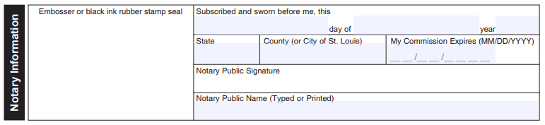
FOR OFFICE USE ONLY
_____________________________________________________________________
ELIGIBILITY VERIFICATION

Approved [ ] Yes [ ] No: Reason:______________________________________________________

